**FAST**

**National University of Computer and Emerging Sciences**



**Web Prgramming**

**Assignment #1**

**Submitted by:**

**Rimsha Sarfraz(21F-9244)**

**BSCS_5E**

**Submitted to: Mam Sumaira Mustafa**

**Dated: 10th Feb ,2024**

**Task 1:**

Code:

<!DOCTYPE html>

<html lang="en">

<head>

<meta charset="UTF-8">

<meta name="viewport" content="width=device-width, initial-scale=1.0">

<title>Rimsha's Calculator</title>

<style>

body {

font-family: 'Arial', sans-serif;

background-color: #f5f5f5;

display: flex;

justify-content: center;

align-items: center;

height: 100vh;

margin: 0;

}

#calculator {

background-color: #34495e; /* Dark blue */

border-radius: 8px;

box-shadow: 0 0 10px rgba(0, 0, 0, 0.3);

padding: 20px;

width: 300px;

text-align: center;

}

input[type="number"] {

width: 90%;

padding: 10px;

margin-bottom: 10px;

box-sizing: border-box;

border: none;

background-color: #ecf0f1;

border-radius: 4px;

}

output {

display: block;

font-size: 1.5em;

padding: 10px;

background-color: #2c3e50;

color: #fff;

border-radius: 4px;

margin-bottom: 10px;

}

button {

width: 40%;

padding: 10px;

font-size: 1.2em;

box-sizing: border-box;

cursor: pointer;

margin: 5px;

border: none;

border-radius: 4px;

background-color: #3498db;

color: #fff;

transition: background-color 0.3s ease;

}

button:hover {

background-color: #2980b9;

}

button:active {

background-color: #1f618d;

}

.operation {

background-color: #9b59b6;

}

.equals {

background-color: #27ae60;

}

.numbers {

display: grid;

grid-template-columns: repeat(3, 1fr);

gap: 10px;

}

</style>

</head>

<body>

<div id="calculator">

<input type="number" id="firstNumber" placeholder="Here enter First Number" />

<input type="number" id="secondNumber" placeholder="Here enter Second Number" />

<output id="result">Result: 0</output>

<div class="numbers">

<button onclick="addNumber(1)">1</button>

<button onclick="addNumber(2)">2</button>

<button onclick="addNumber(3)">3</button>

<button onclick="addNumber(4)">4</button>

<button onclick="addNumber(5)">5</button>

<button onclick="addNumber(6)">6</button>

<button onclick="addNumber(7)">7</button>

<button onclick="addNumber(8)">8</button>

<button onclick="addNumber(9)">9</button>

<button onclick="addcharacter('.')">.</button>

<button onclick="addNumber(0)">0</button>

<button onclick="addcharacter('00')">00</button>

</div>

<div>

<button class="operation" onclick="performOperation('+')">+</button>

<button class="operation" onclick="performOperation('-')">-</button>

<button class="operation" onclick="performOperation('*')">*</button>

<button class="operation" onclick="performOperation('/')">/</button>

<button class="equals" onclick="calculate()">=</button>

</div>

</div>

</body>

</html>

Output:

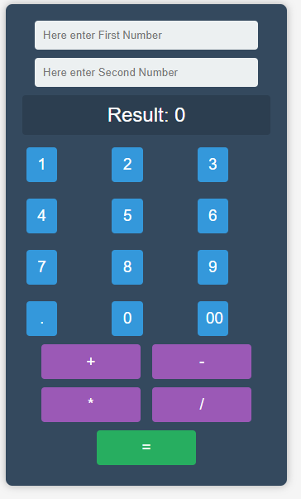

**Task 2:**

**Code:**

<!DOCTYPE html>

<html lang="en">

<head>

<meta charset="UTF-8">

<meta name="viewport" content="width=device-width, initial-scale=1.0">

<title>Time Table</title>

<style>

body {

font-family: 'Arial', sans-serif;

background-color: #f5f5f5;

padding: 20px;

}

table {

width: 100%;

border-collapse: collapse;

}

th, td {

border: 1px solid #000000;

padding: 10px;

text-align: center;

}

th {

background-color: #ffffff;

color: #000000;

}

td {

background-color: #fff;

}

.day {

font-weight: bold;

}

.subject-cell {

background-color: #ffffff;

}

h2, h3 {

text-align: center;

}

</style>

</head>

<body>

<h2>Department of Computer Science</centre></h2>

<h3><centre>BSCS 6E</centre></h3>

<table>

<thead>

<tr>

<th class="empty"></th>

<th>8:45 - 9:15</th>

<th>9:15 - 9:45</th>

<th>9:45 - 10:10</th>

<th>10:15 - 10:45</th>

<th>10:45 - 11:15</th>

<th>11:15 - 11:40</th>

<th>11:45 - 12:15</th>

<th>12:15 - 12:45</th>

<th>12:45 - 1:10</th>

<th>1:10 - 1:40</th>

<th>1:45 - 2:15</th>

<th>2:15 - 2:45</th>

<th>2:45 - 3:10</th>

<th>3:15 - 3:45</th>

<th>3:45 - 4:15</th>

<th>4:15 - 4:40</th>

</tr>

</thead>

<tbody>

<tr>

<td class="day">Mon</td>

<td class="subject-cell" colspan="1"></td>

<td class="subject-cell" colspan="1"></td>

<td class="subject-cell" colspan="1"></td>

<td class="subject-cell" colspan="3">Web Programing <br> <br><br><br><br>Mam Sumaira Mustafa</td>

<td class="subject-cell" colspan="3">Parallel and Ditributed <br>Computing <br><br><br><br>Prof.Haseeb Arshad</td>

<td class="subject-cell" colspan="1"></td>

<td class="subject-cell" colspan="3">Artificial Intelligence<br> <br><br><br><br>Prof.Ali Raza </td>

<td class="subject-cell" colspan="1"></td>

<td class="subject-cell" colspan="1"></td>

<td class="subject-cell" colspan="1"></td>

</tr>

<tr>

<td class="day">Tue</td>

<td class="subject-cell" colspan="3">Computer Networks<br> <br><br><br><br> Dr.Umar Aftab </td>

<td class="subject-cell" colspan="3">Artificial Intelligence<br> <br><br><br><br>Prof.Ali Raza</td>

<td class="subject-cell" colspan="1"></td>

<td class="subject-cell" colspan="1"></td>

<td class="subject-cell" colspan="1"></td>

<td class="subject-cell" colspan="1"></td>

<td class="subject-cell" colspan="6">Artificial Intelligence Lab<br> <br><br><br><br>Prof.A.Tabassum</td>

</tr>

<tr>

<td class="day">Wed</td>

<td class="subject-cell" colspan="1"></td>

<td class="subject-cell" colspan="1"></td>

<td class="subject-cell" colspan="1"></td>

<td class="subject-cell" colspan="1"></td>

<td class="subject-cell" colspan="1"></td>

<td class="subject-cell" colspan="1"></td>

<td class="subject-cell" colspan="1"></td>

<td class="subject-cell" colspan="1"></td>

<td class="subject-cell" colspan="1"></td>

<td class="subject-cell" colspan="1"></td>

<td class="subject-cell" colspan="6">Computer Networks Lab<br> <br><br><br><br>Prof.Ali Hamza</td>

</tr>

<tr>

<td class="day">Thu</td>

<td class="subject-cell" colspan="1"></td>

<td class="subject-cell" colspan="1"></td>

<td class="subject-cell" colspan="1"></td>

<td class="subject-cell" colspan="3">Computer Networks<br> <br><br><br><br> Dr.Umar Aftab </td>

<td class="subject-cell" colspan="3">Software Design and <br>Analysis <br><br><br><br>Prof.Awais Azam</td>

<td class="subject-cell" colspan="1"></td>

<td class="subject-cell" colspan="3">Web Programing <br> <br><br><br><br>Mam Sumaira Mustafa</td>

<td class="subject-cell" colspan="3">Parallel and ditributed <br>Computing <br><br><br><br>Prof.Haseeb Arshad</td>

<tr>

<td class="day">Fri</td>

<td class="subject-cell" colspan="1"></td>

<td class="subject-cell" colspan="1"></td>

<td class="subject-cell" colspan="1"></td>

<td class="subject-cell" colspan="3">Software Design and <br>Analysis <br><br><br><br>Prof.Awais Azam</td>

<td class="subject-cell" colspan="1"></td>

<td class="subject-cell" colspan="1"></td>

<td class="subject-cell" colspan="1"></td>

<td class="subject-cell" colspan="1"></td>

<td class="subject-cell" colspan="1"></td>

<td class="subject-cell" colspan="1"></td>

<td class="subject-cell" colspan="1"></td>

<td class="subject-cell" colspan="1"></td>

<td class="subject-cell" colspan="1"></td>

<td class="subject-cell" colspan="1"></td>

</tr>

</tbody>

</table>

</body>

</html>

**Output:**

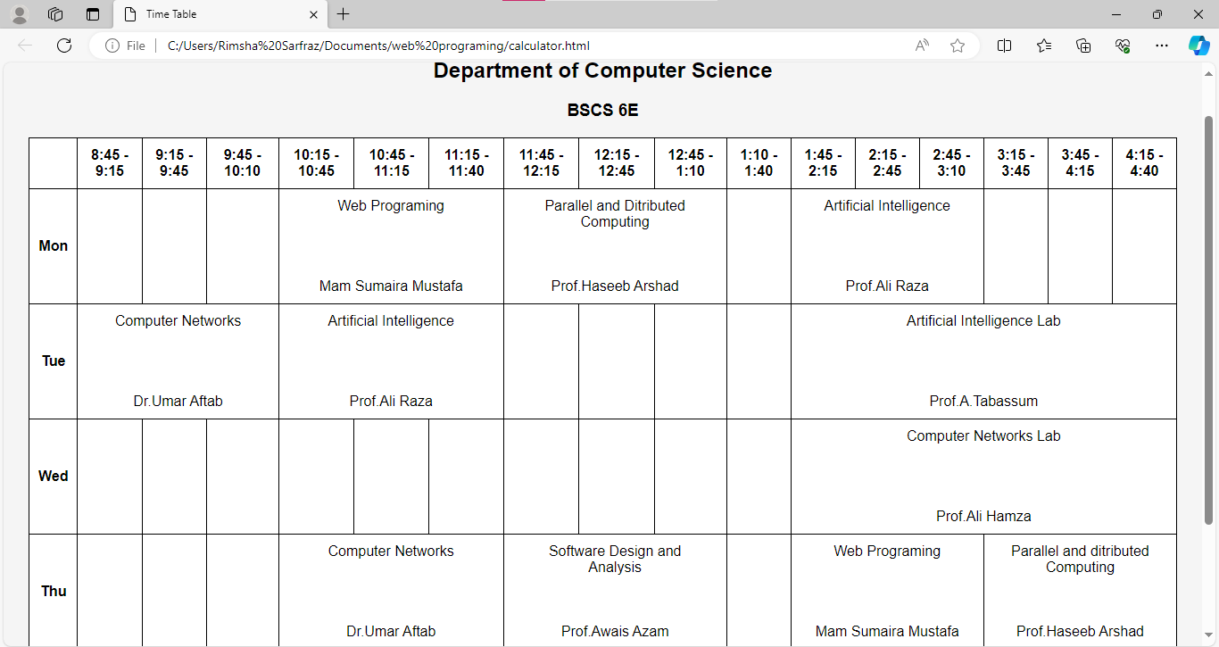

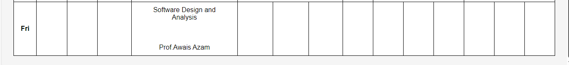

Less Zoom view

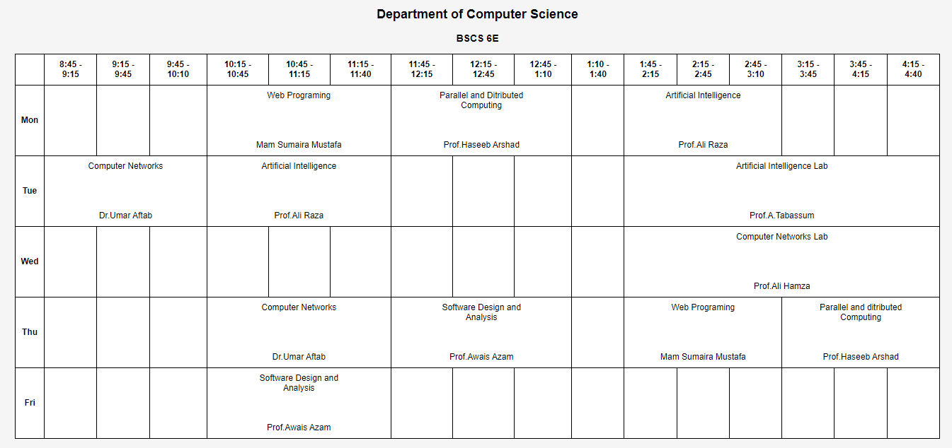

**Task 3:**

Code:

<!DOCTYPE html>

<html lang="en">

<head>

<meta charset="UTF-8">

<meta name="viewport" content="width=device-width, initial-scale=1.0">

<title>Rimsha_CV</title>

<style>

body {

font-family: Arial, sans-serif;

margin: 0;

padding: 0;

background-color: #f5f5f5;

color: #fff;

}

.container {

display: flex;

max-width: 1000px;

margin: 20px auto;

background-color: #666;

border-radius: 10px;

overflow: hidden;

}

.section {

flex: 1;

padding: 20px;

}

.section.left-section {

background-color: #444;

}

.section.right-section {

background-color: #555;

}

h1, h2, h3 {

margin-top: 0;

}

h1 {

text-align: center;

}

h2 {

border-bottom: 2px solid #fff;

padding-bottom: 10px;

margin-bottom: 20px;

}

ul {

list-style-type: none;

padding: 0;

margin: 0;

}

ul li {

margin-bottom: 10px;

}

.button {

display: inline-block;

padding: 10px 20px;

background-color: #007bff;

color: #fff;

text-decoration: none;

border-radius: 5px;

transition: background-color 0.3s ease;

}

.button:hover {

background-color: #0056b3;

}

.contact p {

margin: 5px 0;

}

.profile-img {

display: block;

width: 150px;

height: auto;

border-radius: 50%;

margin-right: 20px;

}

</style>

</head>

<body>

<div class="container">

<div class="section left-section">

<img class="profile-img" src="butterfly.jpg.jpg" alt="Profile Picture">

<h1>Rimsha Sarfraz</h1>

<div class="section">

<h2>Contact Information</h2>

<ul>

<li>Email: f219244@cfd.nu.edu.pk</li>

<li>Phone: +1234567890</li>

<li>GitHub: github.com/Rimsha</li>

</ul>

</div>

<div class="section">

<h2>Education</h2>

<ul>

<li>Bachelor of Science in Computer Science - Fast National University(2024)</li>

</ul>

</div>

<div class="section">

<h2>Languages</h2>

<ul>

<li>Urdu (Fluent)</li>

<li>English (Fluent)</li>

<li>Arabic (Intermediate)</li>

</ul>

</div>

</div>

<div class="section right-section">

<div class="section">

<h2>Work Experience</h2>

<ul>

<li>Software Developer - Devsinc Company Islamabad (2024 - Present)</li>

<li>Intern - Qbatch company(20222 - 2023)</li>

</ul>

</div>

<div class="section">

<h2>Skills</h2>

<ul>

<li>Programming Languages: Java, Python, JavaScrip,C++t</li>

<li>Web Development: HTML/CSS </li>

<li>Database Management: SQL </li>

<li>Operating System: Kernel and user Level</li>

</ul>

</div>

<div class="section">

<h2>Hobbies</h2>

<ul>

<li>Photography</li>

<li>Reading</li>

<li>Hiking</li>

</ul>

</div>

<div class="section">

<h2>Summary</h2>

<p>Recent graduate with a degree in Computer Science and a passion for building seamless and functional user interfaces. Seeking a role to apply exceptional ability to switch between programming languages and frameworks as needed, while working quickly and independently.</p>

</div>

<a href="#" class="button">Download CV</a>

</div>

</div>

</body>

</html>

Output:

